AW1-11
Prescribed by Secretary of State
Sections 4.004, 83.010, 85.004, 85.007, Texas Election Code 9/2009

AMENDED FOR ALL POLITICAL SUBDIVISIONS EXCEPT COUNTIES

NOTICE OF GENERAL ELECTION (AVISO DE ELECCION GENERAL)

To the registered voters of Fayette County, Texas:

(A los votantes registrados Fayette County, Texas)

Notice is hereby given that the polling places listed below will be open from 7:00 a.m. to 7:00 p.m., on November 3, 2020, for voting in a general election to elect a Board Member to the Lee-Fayette Counties Cummins Creek Water Control and Improvement District #1.

Por la presente se notifica que los lugares de votación que se enumeran a continuación estarán abiertos de 7:00 a.m. a 7:00 p.m., el 3 de noviembre de 2020, para votar en una elección general para elegir un miembro de la Junta para los condados de Lee-Fayette Cummins Creek Water Distrito de Control y Mejoramiento # 1.

On Election Day, voters must vote in their precinct where registered to vote.
(El Día de Elección, los votantes deberán votar en su precinto donde están inscritos para votar.)

Location of Election Day Polling Places Include Name of Building and Address (Ubicación de las casillas electorales el Día de Elección) (Incluir Nombre del Edificio y Dirección) | Precinct Number(s)  (Número de precinto)
Herman Sons Hall; 5830 SH 159, La Grange TX 78945 | Precinct 2
Fayetteville Community Center; 202 Main St.; Fayetteville, TX 78940 | Precinct 4
Minssen’s Store; 6808 SH 159, Fayetteville TX 78940 | Precinct 5
St. John’s Lutheran Church; 4446 S SH 237, Round Top TX 78954 | Precinct 6
Round Top Courthouse; 201 Main St; Round Top, TX 78954 | Precinct 7
Carmine Volunteer Fire Department; 118 Augsburg Ave; Carmine TX 78932 | Precinct 8
Waldeck Lutheran Church Annex; 6915 Waldeck Church Lane, Ledbetter TX 78946 | Precinct 9
Holy Cross Lutheran Church Fellowship Hall; 600 FM 1482, Giddings TX 78942 | Precinct 10

For early voting, a voter may vote at any of the locations listed below:
(Para Votación Adelantada, los votantes podrán votar en cualquiera de las ubicaciones nombradas abajo.)

Locations for Early Voting Polling Places Include Name of Building and Address  (Ubicación de las casillas electorales de votación adelantada) | Days and Hours of Operation  Días y Horas Hábiles
Fayette County Courthouse Room #108; | Tuesday, October 13 through Friday, October 16 from 7 am to 7 pm
La Grange, TX 78945 | Saturday, October 17 from 9 am to 3 pm
 | Sunday, October 18 from 11 am to 3 pm
 | Monday, October 19 through Friday, October 23 from 7 am to 7 pm
 | Saturday, October 24 from 9 am to 3 pm
 | Sunday, October 25 from 11 am to 3 pm
 | Monday, October 26 through Friday, October 30 from 7 am to 7 pm

Applications for ballot by mail shall be mailed to:
(Las solicitudes para boletas de votación adelantada por correo deberán enviarse a:)

TERRI HEFNER

(Name of Early Voting Clerk)
(Nombre del Secretario de la Votación Adelantada)

PO BOX 605/151 N. WASHINGTON ST ROOM #108
(Address) (Dirección)

LA GRANGE 78945
(City) (Ciudad) (Zip Code) (Código Postal)

Applications for ballots by mail must be received no later than the close of business on: October 23, 2020.
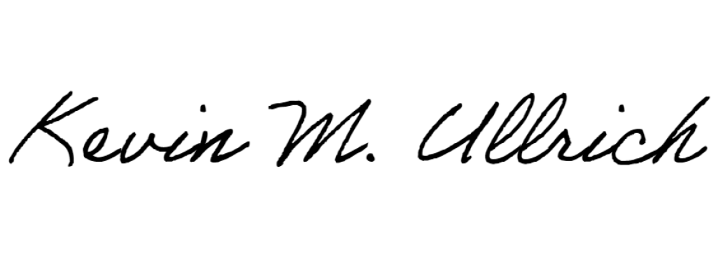(Las solicitudes para boletas de votación adelantada por correo deberán recibirse para el fin de las horas de negocio el: 23 de octubre de 2020).
Signature of Presiding Officer (Firma del Oficial que Preside)
Signature of Presiding Officer (Firma del Oficial que Preside)

Issued this the 2nd day of September, 2020.
(Publicado el 2 de septiembre de 2020.)

Amended this the 21st day of September, 2020. (Publicado el 2 de septiembre de 2020.)

